RESOLUTION NO.__________

RE: CERTIFICATE OF APPROPRIATENESS UNDER THE
PROVISIONS OF THE ACT OF THE PENNSYLVANIA
LEGISLATURE 1961, JUNE 13, P.L. 282 (53
SECTION 8004) AND BETHLEHEM ORDINANCE NO.
3952 AS AMENDED.

WHEREAS, it is proposed to replace an existing blade sign with a new sign at 574 Main St.

NOW, THEREFORE, BE IT RESOLVED by the Council of the City of Bethlehem that a Certificate of Appropriateness is hereby granted for the proposal.

Sponsored by: (s)

(s)

ADOPTED BY COUNCIL THIS DAY OF

(s)
President of Council

ATTEST:

(s)
City Clerk

HISTORICAL & ARCHITECTURAL REVIEW BOARD

The applicant is proposing to replace an existing blade sign with a new sign at 574 Main St.
APPLICATION #2:

Able Pay (John Fistner)
574 Main St.
Bethlehem, PA 18018

518 Main St.
Bethlehem, PA 18018

OWNER:

__________________________________________________________________________

The Board upon motion by Beth Starbuck and seconded by Marsha Fritz adopted the proposal that City Council issue a Certificate of Appropriateness for the following:

- Existing sign to be replaced with new carved sign.

2. To include a pinstripe in either off-white or red.

3. The motion was unanimously approved.

__________________________________________________________________________

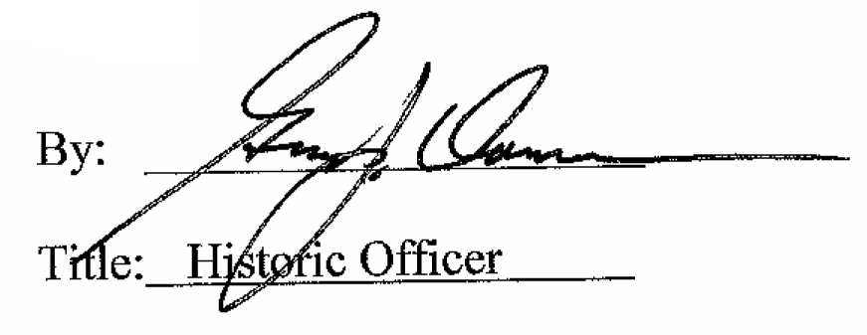

Date of Meeting: January 3, 2018

